Environmental Effects
Another disaster struck North Carolina close to home. Hurricane Florence was the second biggest hurricane since Matthew in 2016. However, Florence did more than just damage people’s houses. The surrounding environment suffered as well. Pollution washed into the local waters and contaminated the wells of several areas, leaving the potable water unusable. Some experts say climate change is the one to blame for the unfortunate timings of these natural disasters and others believe it’s a historical pattern. Hurricane Florence left its mark in North Carolina and whether it has affected our everyday lives is more than meets the eye.
Pollution
Hurricane Florence caused pollution in various areas of the Southeast. Flooding resulted in waste from hog farms being washed into the local waters and nearly 650,000 wells becoming what Stateline news source describes as a “toxic soup” of contaminants.
About 10 billion gallons of wet animal waste, swine and cattle, are produced each year in North Carolina according to a study conducted by the Environmental Working Group (EWG) and the Waterkeeper Alliance.
Around 4,145 waste pits extend across 6,848 acres of North Carolina’s countryside. These hog lagoons are often located along the coastal plains in an area with a higher water table and high rates of poverty and minorities. A large number of wells – 136 waste pits are within a half mile of a public water well and 170 waste pits are within the state’s 100-year floodplain.
More than 30 above-ground hog lagoons overflowed in North Carolina after the hurricane, carrying pig waste into the water of surrounding communities. Six of the lagoons were structurally damaged during the flooding.
Lucy Holmes lives in Maple Hill, a town in Pender County which is located between Wilmington and Jacksonville. Her home was impacted by Florence that resulted in...
Floodwater reach the porch of Lucy Holmes’ home in Maple Hill, N.C.
(Submitted photo).
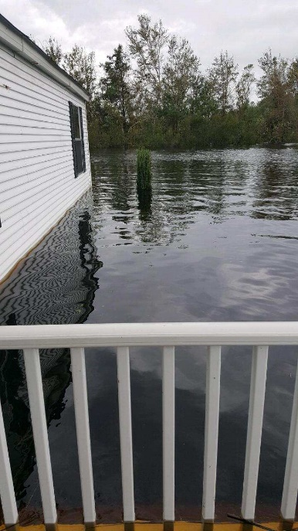
According to an article in Pacific Standard, North Carolina is the second-largest producer of pork in the United States – go figure since every town has a barbeque joint around the corner – containing counties with 25 times as many hogs as people.
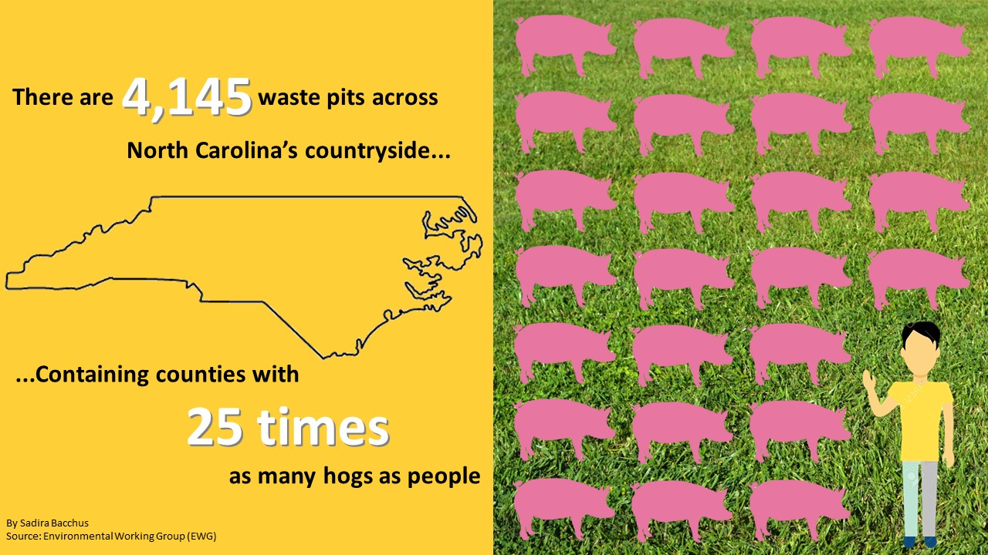
For years, this industry was unregulated, and the waste was untreated. Today, there is still no treatment requirements for animal waste in North Carolina.
Contamination also can be traced to waste water treatment plants that overflowed and discharged millions of gallons of raw sewage into flooded rivers, as well as from private septic tanks expelling human waste when they were submerged. Floodwater from Florence also contained agricultural runoff, fuel and other contaminants that can seep into the groundwater through aquifer ventilation systems, according to Stateline.
These systems are underground units that store thermal energy (natural heat/cold in air, soil and water, solar energy, and waste heat from mechanical processes) for seasonal purposes. This makes it possible to capture the warmth of summer to use for heating in the winter or the cold of winter to use for cooling in the summer.
The National Ground Water Association estimated that 332,798 private wells were exposed to heavy rains or located in counties declared disaster areas from the hurricane. However, North Carolina does not require regular testing of private wells so there is no comprehensive data available on the levels of contamination caused by flooding.
Around 646 samples tested recently by the State Laboratory of Public Health showed an increase in E. coli, bacteria that indicates the presence of fecal matter found in raw sewage and in animal waste.
According to an article in the Raleigh News & Observer, results show that 14.9 percent of the well water tested positive for E. coli and total fecal coliform bacteria, as compared to the 2 percent of private wells that tested positive for those same pathogens between January and September, before Hurricane Florence. These bacteria indicate that the water contains pathogens that can cause stomach sickness and are potentially dangerous to those with a weak immune system.
Although Columbus County – Robeson County’s next door neighbor – saw a corresponding increase in stomach illness and more than 130 wells in North Carolina were contaminated with E. coli, it is not clear that this is due to drinking bad well water.
Robeson County residents were asked to participate in a research project undertaken by The University of Chapel Hill, N.C. State University and Virginia Tech to analyze the water quality of their private wells. The third round of tests were conducted in November 2018.
The testing was not a result of the contamination found in well water. It was done as an educational exercise to inform people about the need to have their well water tested regularly to guarantee a continuous supply of high-quality water said Michael Burchell, associate professor of biological and agricultural engineering at N.C. State.
According to an article in The Robesonian, the goal is to move toward a regional or state well testing program so that people always know their water quality.
Climate Change
One thing North Carolina wasn’t prepared for was the drastic change in climate that would affect the patterns of hurricanes. According to Berkeley Earth, 2018 was the fourth warmest year on record which is consistent with the long-term warming trend.
Some scientists believe it is the result of a very strong El Nino event that causes global changes in temperature and rainfall. However, the National Oceanic and Atmospheric Administration (NOAA) said the absence of El Nino during the season, warmer Atlantic Ocean temperatures and a stronger west African monsoon helped enhance the storm’s development.
Hurricane Florence was North Carolina’s wettest storm, dropping more than 8 trillion gallons of water according to the National Weather Service. Some areas received as much as 35 inches of rain, which caused many communities to experience tremendous flooding.
As average temperatures rise, air can hold on to more moisture so when it rains heavy, more water is dumped throughout the years. According to Vox, that is why some scientists describe climate change’s impacts on extreme weather as “loading the dice.”
When forecasters track a hurricane, they use models from several different supercomputers around the world to create predictions. The two most used models are the European and the American model.
Both models perform the same job, but which one is better?
During Hurricane Sandy, the European model predicted eight days before landfall that the storm would hit the East Coast, while the American model showed Sandy drifting out to sea according to an article in the Boston Globe. However, for Hurricane Florence, the American model had the better prediction according to an article in The Washington Post.
Results vary storm to storm, yet typically the European model comes out on top as the most accurate.
Before Florence struck, the European model was “at its finest”. It suggested the storm would hit the Carolinas, while the American model incorrectly predicted it would stay out at sea.
Precipitation total ranks third wettest on record in the nation. This year the U.S. encountered 15 named storms and eight hurricanes, two of which were “major” – being a Category 3, 4 or 5 storm – compared to the average season of 12 named storms, six hurricanes and 3 major hurricanes according to the National Oceanic and Atmospheric Administration.
Several river forecasts locations in the Carolinas approached or broke their record flood level in the days and weeks of the storm, 16 rivers being in North Carolina.
According to Pew, landlocked states received the most impact from hurricanes. Like Florence, Hurricane Michael did more damage inland due to excessive rainfall.
It is predicted that the 2019 hurricane season will start earlier than its usual time, beginning June 1, and that more storms in the coming years will mirror Florence.
Lumber River
The Lumber River reached new heights during Hurricane Florence that were higher than previous storms. The river is the only blackwater river in North Carolina designated as a National Wild and Scenic River. It is 133 miles long, starting from the Scotland County-Hoke County border and ending at the North Carolina-South Carolina border. Soon after crossing into South Carolina, the Lumber River flows into the Little Pee River, which flows into the Great Pee Dee River and on into the Winyah Bay and the Atlantic Ocean.
Eventually, anything that goes in the river ends up in the ocean.
The Lumber River and its adjoining water banks are part of the Lumber River State Park, which covers 9,874 acres of land and 115 miles of waterway.
So, how is flooding handled?
The town of Pembroke is located within the watershed of the Lumber River. Although the watershed is relatively small, the low gradient (low flow) of the Robeson County area plus high amounts of precipitation during short periods of time can easily cause flooding according to Dr. Jeff Chaumba, associate professor of geology at UNC Pembroke.
The Lumber River is considered a second-growth oak-cypress-gum swamp forest of the blackwater subtype, meaning the river is protected and certain procedures such as building a floodwall cannot be done according to Lane Garner, park superintendent of Lumber River State Park.
Blackwater is the term to describe the color of the water that is caused by the tannins (complex chemical substances derived from phenolic acids) that filter into the river from surrounding vegetation and debris on the ground, he said.
“There is many rules and regulations that is set forth by the U.S. Corp of Engineers that regulate what structures can be built on the river,” said Garner.
Hurricane Florence washed away roads, trails and campsites and caused many trees to fall, especially up and down the river, he said. Some of the wildlife migrated to higher ground.
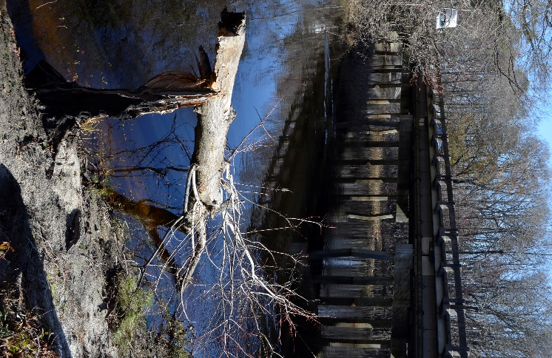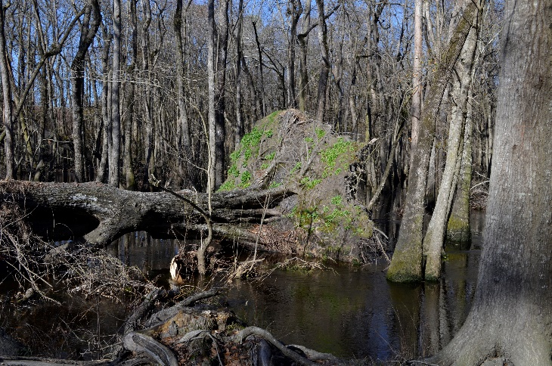
Fallen trees near the Lumber River by Harpers Ferry Baptist Church in Maxton, N.C.
photos by Sadira Bacchus
The Lumber River crested between 25.3 and 25.5 feet during Florence according to an article in The Robesonian. The park was still clearing the debris from Matthew on an 80-mile section of the river when Florence hit, Garner said.
The plants along the river essentially don’t prevent flooding and instead, lessen the risk of pollution in the river water.
“These plants provide stabilization from erosion and provide a buffer to help prevent contaminants from entering the river,” Garner said.
Construction within the flood zone is changing according to Garner. He believes that areas around the river should consider elevating their structure or building on higher ground.
500-year Storm
Hurricane Florence showed the effects of a “1,000-year” event over the period of three days.
Don’t get confused because we’re talking not about history but about probability.
The severity of floods is explained in terms of years: 100-year, 500-year, and 1,000-year. This particular description is used to predict the chance of a flood occurring in a year. A 100-year flood is a 1 percent chance, whereas a 500-year flood is a 0.2 percent chance, with the risk increasing every 30 years said Dr. Martin Farley, chair of geology and geography at UNC Pembroke. A 1,000-year flood means it has a 0.1 percent chance of occurring in any given year.
However, the problem is that 500-year floods are happening more often than probability predicts like Hurricane Harvey in Houston. Prevention planning hasn’t evolved to acknowledge that a “500-year” flood isn’t really a 1-in-500 chance anymore.
Areas struck by Florence failed to act on the changing risks. North Carolina passed a bill in 2012 to ban the use of modern climate science in forecasting threats from flooding and rising seas, known as HB 819. The bill’s central focus is about property values and business interests along the coast.
According to a 2010 North Carolina Sea-Level Rise Assessment Report, it was predicted that the ocean would likely reach 39 inches higher or more by the year 2100. Business groups feared that it would hinder economic development in the region, so they fought against its inclusion in aspects of coastal management – and for the most part succeed according to an article in Science Alert. Old assessments of floodplains are becoming obsolete, which puts more people and property at risk.
Solutions
Now that North Carolina has had its share of natural disasters, what can be done to make sure that the effects are not as devastating? Flooding is a major situation and should be resolved to better protect not only the people, but the environment.
According to an article in the Water Well Journal, many well owners avoid testing for fear that their wells could be declared unsafe or condemned, therefore hurting their property value. Get your water tested regularly and clear it of dangerous bacteria that may be a result of polluted soils. This will save you the trouble in the long-run.
Simple acts such as avoiding littering can help reduce flooding in probable areas.
“Any trash in the watershed of the Lumber River eventually ends up either increasing the amount of material that has to be drained away by the flooded rivers or can potentially clog the storm water drains and pipes, worsening the situation,” Chaumba said.

